2017494095 李启佳

**About <Tab> key in the Linux OS**

1. Software programming development, code development is still mostly done via text, or Command Line Interface (CLI).

1. Many of the commands and/or input arguments are complex (e.g. SN20181219shzbarjbl00173646dbx568.log)! It is very error prone to the human fat finger syndrome…
2. Is there a better way than typing or copy/paste the cmd/args per every instruction?
3. Linux OS accommodates this. (In case you don’t have a PC, you can do it via this online website:

<https://bellard.org/jslinux/vm.html?url=https://bellard.org/jslinux/buildroot-x86.cfg>

1. On your Linux platform, practice this command: ls /usr/bin

We have too many commands, which one you want to run? Let’s explore any commands that begin with the letter “w”, ***then follow by a TAB-key (double tab keys if needed)***. Below is the response I saw:

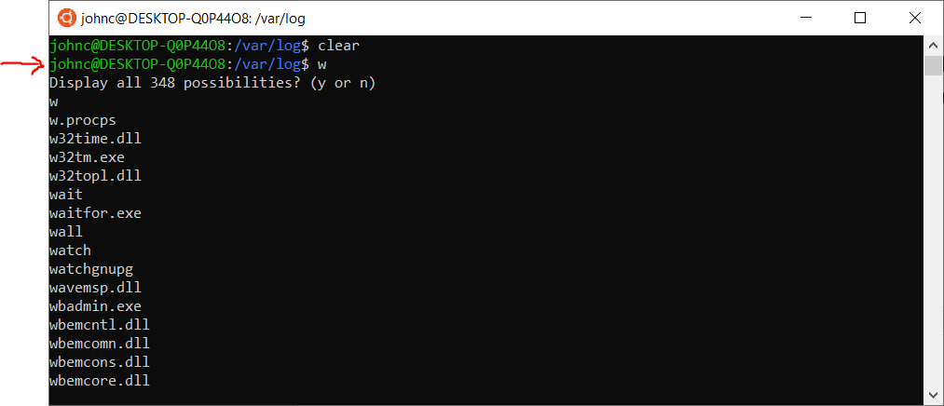

1. The response has a lengthy list, so I narrow down the “search” by entering “wc”, ***followed by*** ***double TAB key strokes***. Below is what I see:

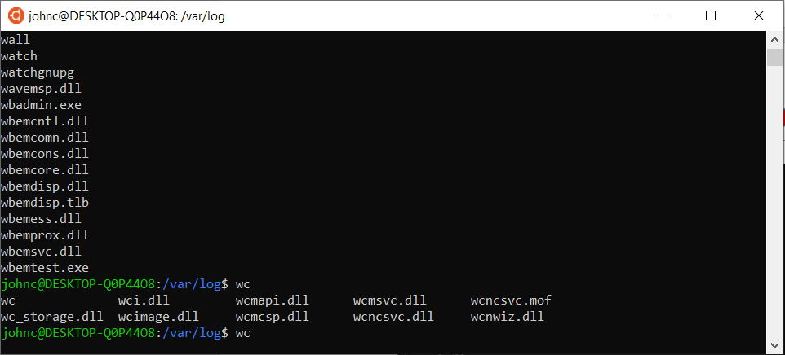

Cool, I find the “wc” command (from the laundry list of commands😊)

1. Let’s ask for help on the command:

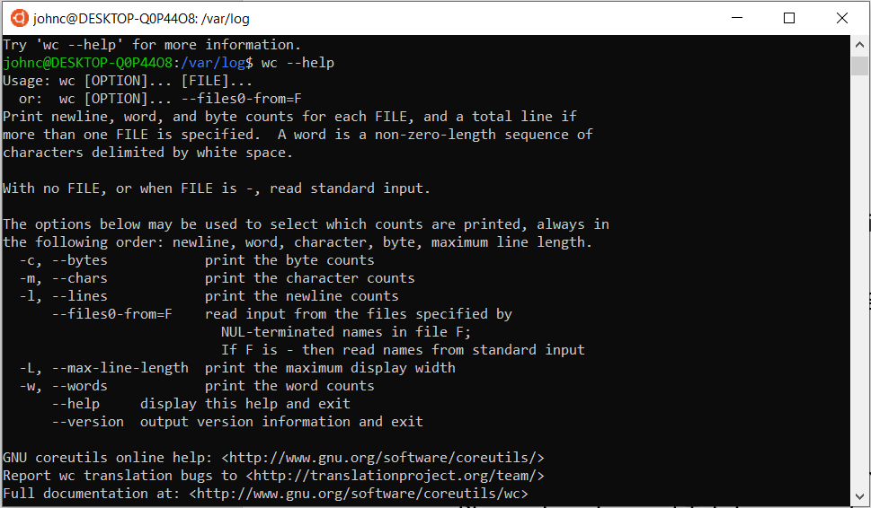

Reflections:

* The beauty and simplicity! (Why this is not in the Window OS?)
* Reflection: CLI vs GUI (Linux, …)
* Can we write software by GUI/Clicking? (e.g. <https://scratch.mit.edu/>, <https://www.drupal.org/>)

**Questions:**

* What does the “Tab”-key do in the Linux OS?

1. list the commands names associated with your input
2. input one or more words. If duplicates are not detected, your file or directory name would be updated completely.

* Do a demo of Tab-key usage above (e.g. commands that begins with letter “p”). Capture your practice session screen shots and pasted below.

I have changed the picture.

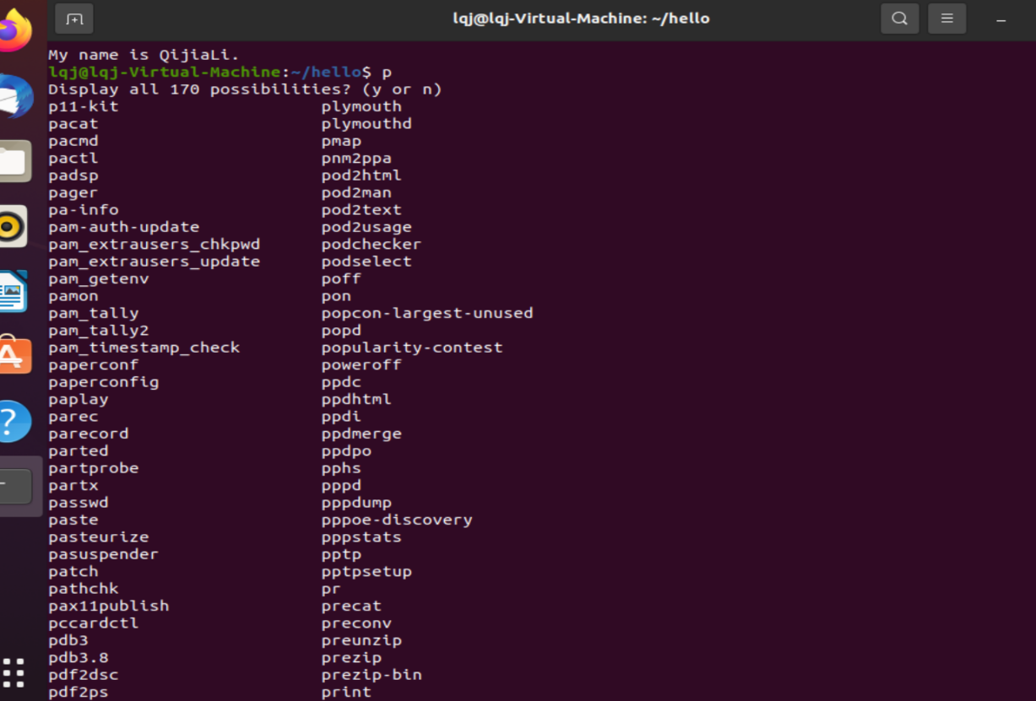

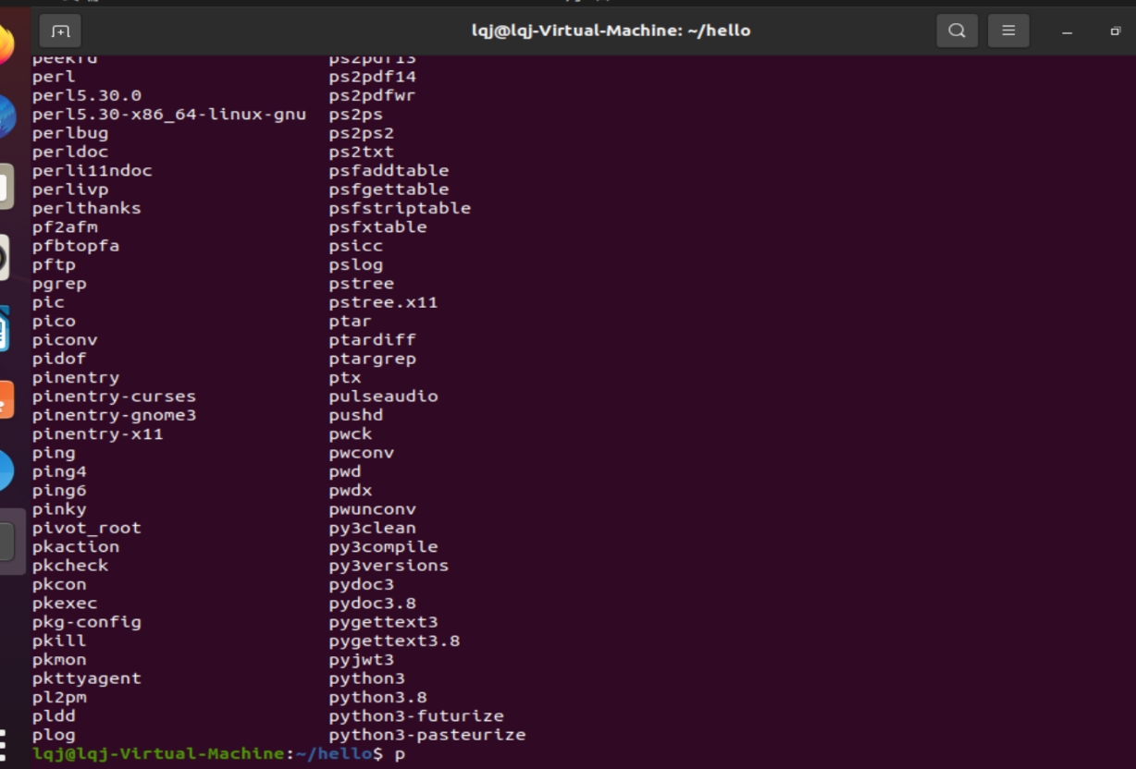

* Do a demo on using the TAB-Key, to search for input arguments to a Linux command. An example is show below (Your practice session results should be different).

I have changed the picture.

I want to use the command wc to deal with the file, like id and selftro. I will show you 🔽

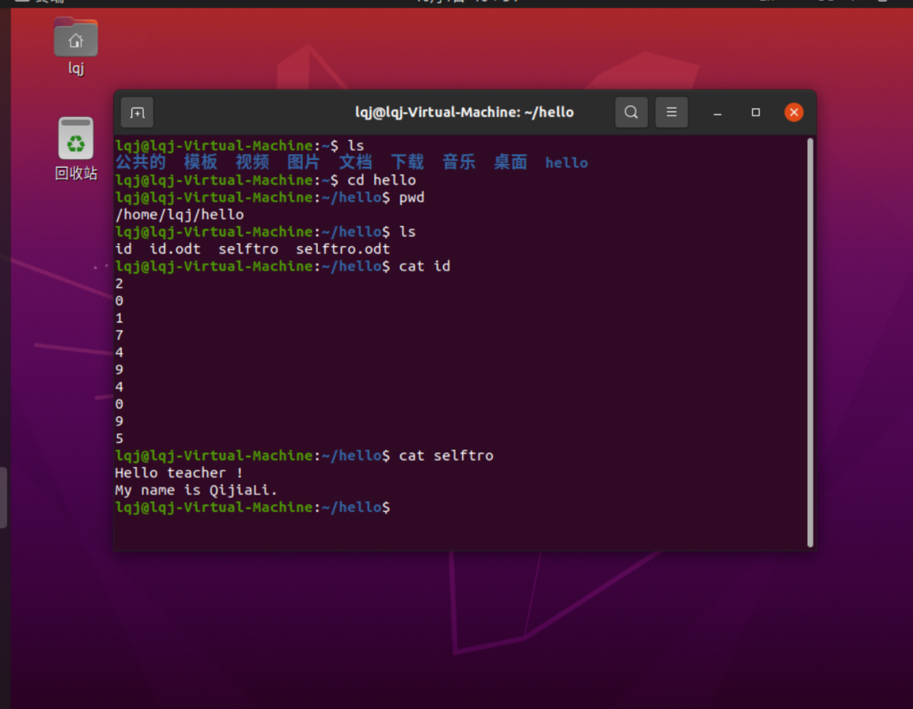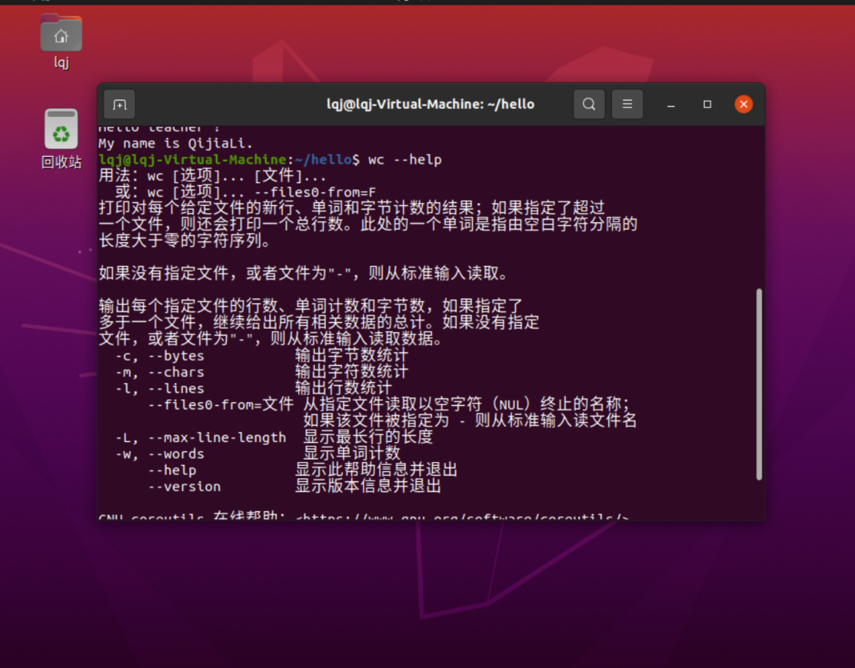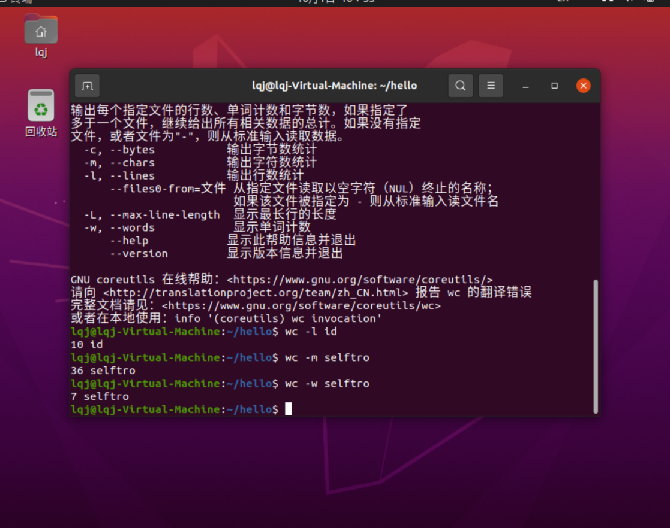

**Lab Assignment Delivery Instructions:**

* *Capture screen shots of your practice session results and paste* ***into this document accordingly****.*
* *Add/Replace the “demo” screen shots seen in this document with your results.*
* *Please elaborate as needed.*
* **Submission:**

Please submit online. If that fails, email your results to: [bangpanliang@gmail.com](mailto:jcc4018@qq.com).

The subject of the email should be: [Your StudentID, Assignment Name]